**Design Exercise 4**

Team members: - Saksham Chandrawat and Shruti Bakare.

**Interview Questions: -**

1. How do you seek for information about the places in a particular city?

2. Which website you go to book your trip?

3. What difficulties you have faced to find good restaurant near you?

4. Are you able to cover most of iconic places without asking anyone?

5. There are many companies who provide city tour but how do you decide to book for your trip?

6. Do you feel not knowing exact prices for tickets in different cities you were cheated by someone?

7. Anytime happened with you we get down somewhere but you did not know operation hours and you missed it. Places like Museums.

**Interview Analysis: -**

We have decided to build a prototype for Android application for tourists. This app will help tourists to visit popular places in the city. This app is one stop guide for tourists visiting NYC. This application includes information regarding famous tourist places in New York City, Famous restaurants, Nightlife, Shopping, Café and events in the city. Hence, it will be easy for the tourists to find all the information in one place.

We interviewed total 9 users for building this application. We received few suggestions for our application. First suggestion we got is regarding the Tourist Attractions. 2 people suggested that, there should be mapping of the tourist places according to their location. For example, if the tourist is near World Trade Center then it should suggest through notification that 9/11 Museum is also in that same area. Hence it will be easier for the tourist to visit the nearby place.

Second suggestion is to add the online payment option for the hotel booking or booking for the museums in the same app. You can add your Debit/Credit card in the Payment method while signing in. Third suggestion is to add one more tab to show nearby public transit options and add tab for shopping purpose. Also users asked to suggest best time to visit option.

In the restaurant tab, there should be option for the people who eat only vegan or Gluten-free food or if they have any food allergies.

**Sketches of the Application: -**

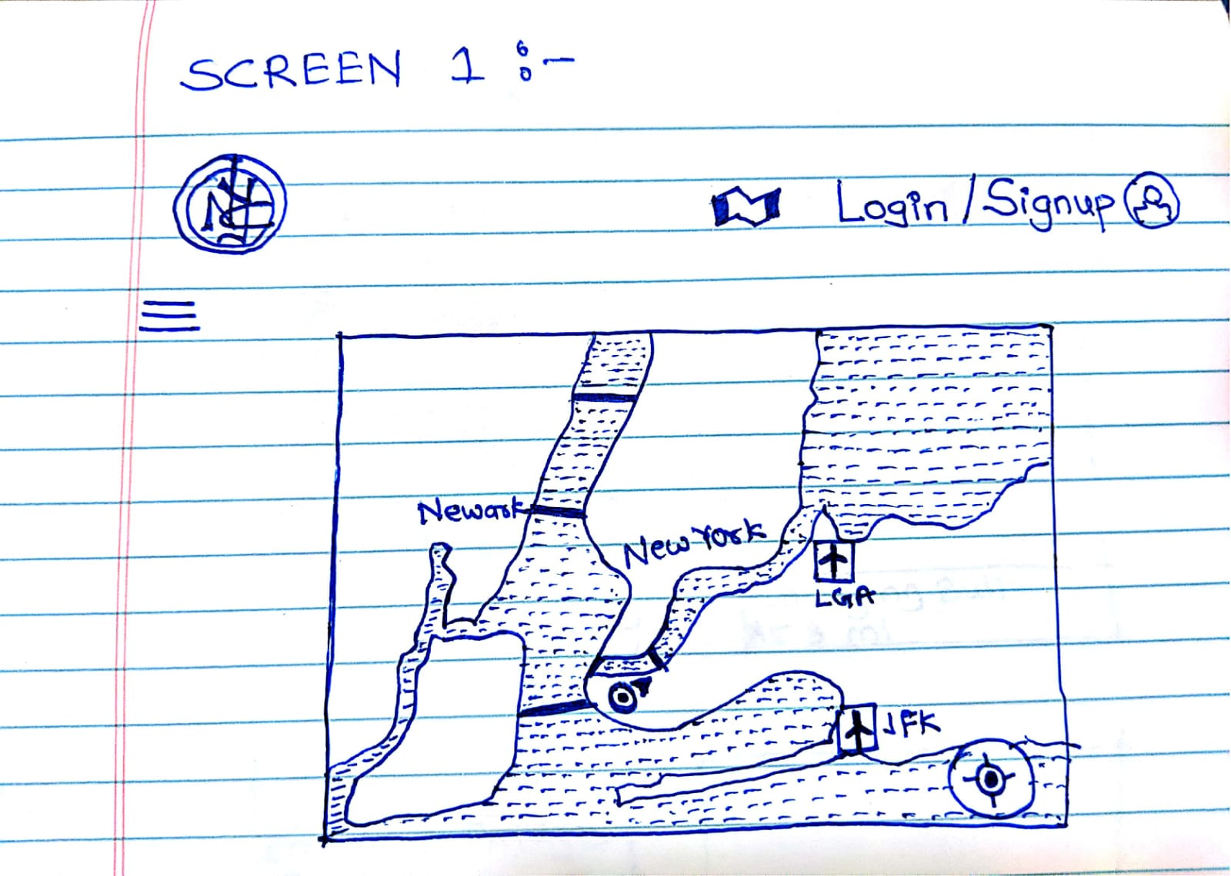

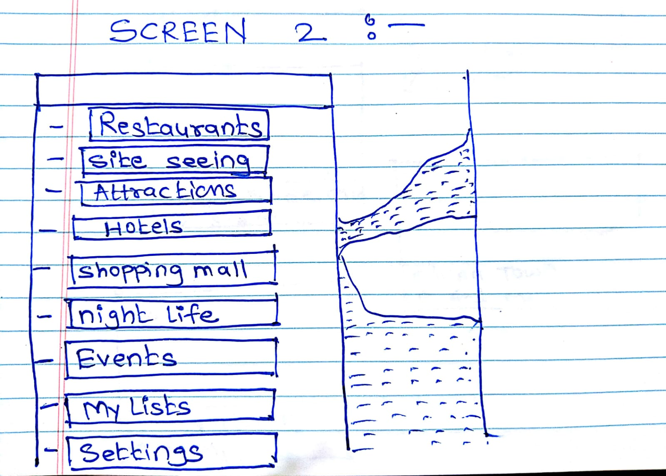

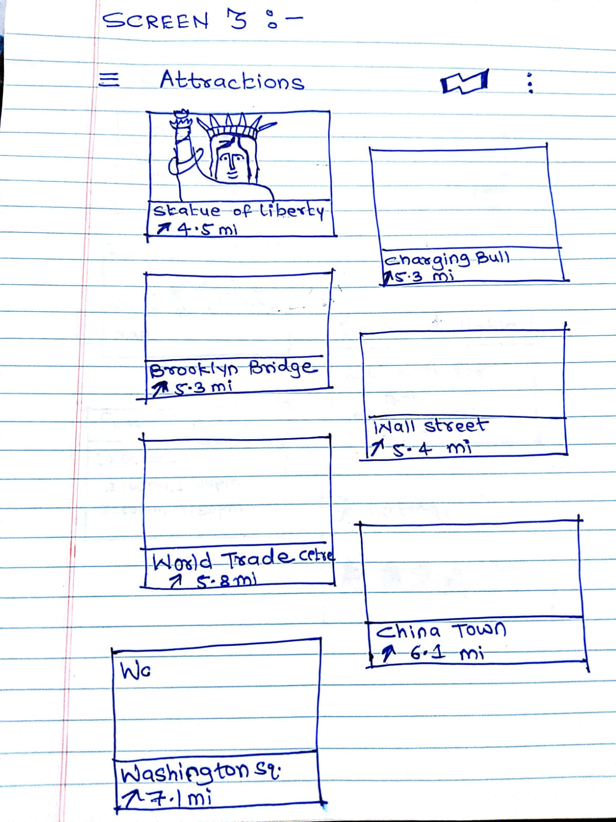

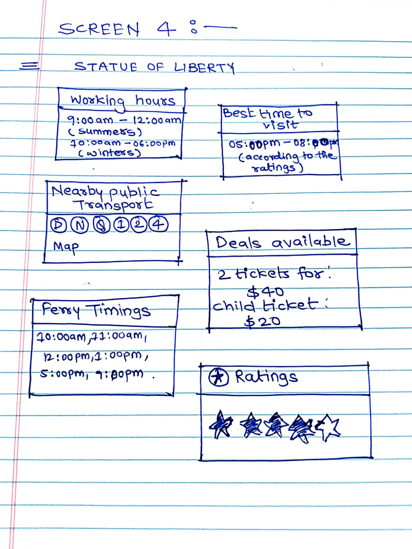

**List of all content topics: -**

1. Attractions: -

* List of attractions on NYC Google map
* Working Hours
* Best time to visit
* Nearby Public Transport
* Deals available

1. Hotels: -

* List of Hotels
* Ratings
* Online Booking option
* Online Payment
* Services provided

1. Restaurants: -

* List of restaurants in the given area
* Type of cuisine
* Ratings for the restaurants
* Food allergies

1. Shopping Malls: -

* List of Shopping places
* Working hours
* Deals and offers available

1. Café: -

* List of Cafes
* Ratings

1. Events: -

* Events organized on that particular date
* Timing
* Prices

1. Nightlife: -

* List of Famous Bars/Disco
* Ratings

1. My Lists: -

* List of favorite places/restaurants/shopping malls, etc.
* Preferences

1. Settings: -

* Sign up
* Sign in
* Payment Method
* Sign Out
* Application Rating